# Istanbul okan university

**Marwan Bakr Mohamed Saeid**

**Computer Engineering department**

**3rd course**







This report’s major aim is to fulfill the duties of a project manager for the designated project of building a hotel within the airport’s proximity to reduce the problem faced by the airline about transporting the crew between the airport and hotels during the time of congestion. In the first part of this report, the project’s scope is discussed concerning the case provided.

In terms of discussing the project’s scope, all the relevant details required to discuss the scope with the project’s stakeholders are covered in this section. In this section of the report, all the project requirements are also communicated to the stakeholders. The next part of the project is related to the risk assessment of the undertaken project.

In this section of the report, the project’s relevant risks are identified along with their respective likelihood and impact of the risks. Moreover, the mitigation strategies and contingency plans about the risks are also stated. The third and final section of the report discusses the project’s milestones by the scope and risks stated in the previous sections.



One of the most important aspects of project management is planning the project, including defining the scope. Project scope management includes the processes, resources, and procedures required to complete the project following the goal and objectives (Guide, 2001). According to PMBOK, there are six steps to be followed to manage the scope of the project (Fitsilis, 2008). To explain the content of this project to the stakeholders, the technicalities of PMBOK are followed.



In this step, the scope management plan is created. In this part, the scope management planning is carried with the project members to assess the approaches that can be used to fulfill the project’s objectives (Sheng, 2018). Initially, with the project team’s help, the scope management plan is designed, which includes the requirements that will help define the needs of the stakeholders, create a Work Breakdown Structure (WBS), validate, and control the scope.

### **Collection of Requirements**

There are several stakeholders of this project, and it is essential to discuss their needs and stake following the completion of this project (Eskerod and Jepsen, 2016). Being the project manager, this task has been carried out with interviews, meetings, and surveys. The first stakeholder of this project is the company itself. By carrying out meetings with the senior management of the company, their stake will be discussed. This project will help the company cut down its cost of partnering up with hotels in Paris to accommodate their 68 crew members every day for a layover.

Moreover, the efficiency will also be increased as the crew will reach the airport in time as the Hotel will be situated within the 10 km proximity of the Hotel. Crew members are also a stakeholder of this project because, via this Hotel, they will not have to travel long routes to reach a place for accommodation as they do it now. This will ultimately increase their productivity.

In this regard, the crew’s major need is to have a hotel near the airport with comfortable rooms to rest. Passengers of the airline traveling from Paris to or via Paris are also the project stakeholders. The new Hotel can be accommodated if the flight is overbooked or if they have missed their connecting flight.

**Definition of scope**

Following the objectives of this project and the requirements of the stakeholders, the following is the scope statement of the project:

“To build a hotel in the proximity of Charles de Gaulle Airport to facilitate the accommodation of crew members during the time of layover and the passengers in case of overbooking of airlines and missed flights in two year time period within the provided budget and constraints.

### **Work Breakdown Structure**

According to the needs of the stakeholders, objectives of the project, and the project’s scope statement that has been discussed in the above section, the following is the WBS that has been designed to facilitate the tasks and activities required to complete the project.

### **Validation of Scope**

This is among one of the final steps of the scope management of the project. The scope statement of the project has already been defined in the preceding section. The management of the airline company, cabin crew, and the contractor appointed for the construction of the Hotel will be provided with the scope statement for validation. Through this process, the scope can improve, Improving how the project is carried out.

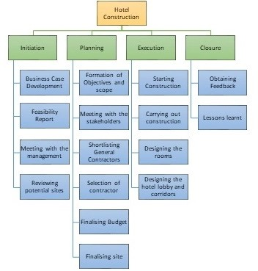



According to Eskerod, Hueman, and Savage (2015), the project scope needs to be well-defined and well-controlled. In this regard, it is ensured that the scope creep does not happen during this project to ensure that there are no unwanted outcomes of the project. For this project, the scope of the project will be validated by the shareholders of the project to make sure that the project is carried out according to the requirements and expectations of the shareholders

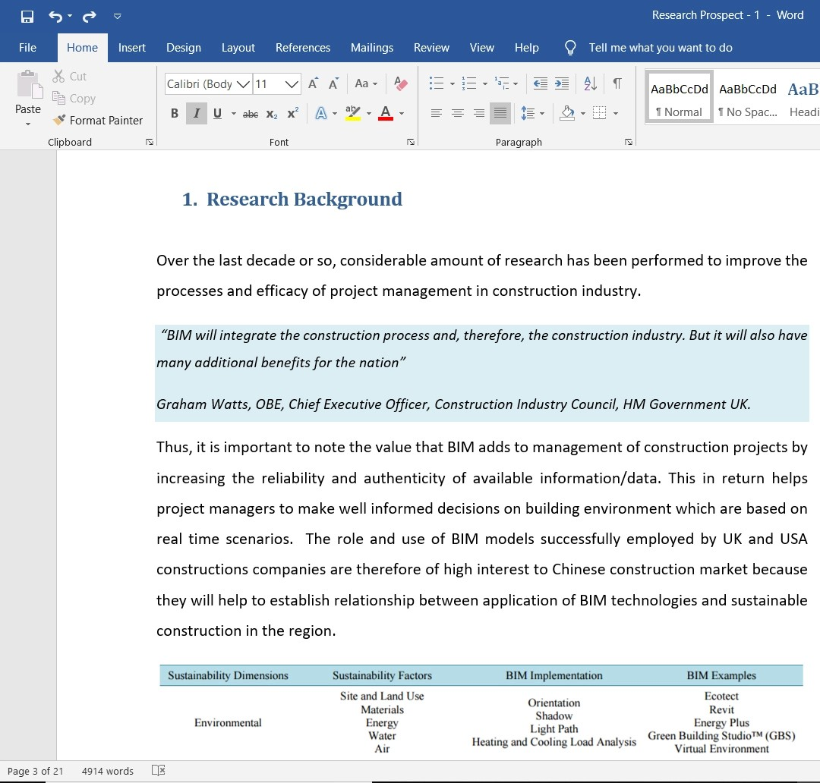

### **Task 2 – Risk Assessment**

For a project to work efficiently, it is essential to avoid and mitigate any potential risk that can harm its successful completion (Haimes, 2015). Before commencing ant project, the project manager’s prime responsibility is to ensure that the risks are identified at the project’s planning phases (Hopkinson, 2017). To ensure that the risks are identified and mitigated efficiently, a risk assessment matrix is formed. This section of the report identifies eight of the significant risks faced by the hotel construction project.

The following table shows the likelihood matrix that explains the probability of the occurrence of the risk during the tenure of the project:

|  |  |  |
| --- | --- | --- |
|  |  |  |
| Very Low | VL | This risk is unlikely to occur during the project |
| Low | L | There are quite low chances of this risk to occur in the project |
| Medium | M | The possibility of occurrence of this risk is not too high neither low |
| High | H | There is a high likelihood of the occurrence of the risk |
| Very High | VH | This risk will probably occur during the project |

**Table 1: Likelihood of Risks**

|  |  |  |
| --- | --- | --- |
|  |  |  |
| Insignificant | I | There is a low to insignificant impact of this risk on the project. |
| Low | L | This risk will impact the project outcome in a minor manner. |

|  |  |  |
| --- | --- | --- |
| Medium | M | There is a moderate impact of such risks on the project. |
| High | H | The impact of the risk on the project is major. |
| Significant | S | This risk will impact the project and its outcomes in a significant manner. |

**Table 2: Impact of Risks**

|  |  |  |  |  |
| --- | --- | --- | --- | --- |
|  |  |  |  |  |
| 1 | The General contractor selected for the project is not efficient; hence the project scope may not be fulfilled. The company selected as the General contractor may go bankrupt. | There is not enough planning and research carried out before finalizing and selecting the General contractor for the construction of the Hotel | Low | Significant |
| 2 | The construction schedule is not followed, which may cause a delay in the project completion. | The scheduling process used and time management of the activities is not carried out by the scope of the project and objectives. | Medium | High |
| 3 | Lack of fund management during the construction project can cause the project resources and funds to suffer. | The planning and budgeting of the project are not carried out efficiently. Fund control company is not appointed | Medium | Medium |
| 4 | Environment, safety, and health issues | During the planning, implementation, and monitoring phase of the project, the safety of the environment and employees was not regarded | Low | High |
| 5 | Natural Disasters such as flooding can hinder the construction activities of the Hotel | While deciding the location and planning of the activities, the likelihood of potential natural disasters was not taken into consideration | Medium | High |
| 6 | The resources and funds available for the activities are not enough. There are not enough funds for completing the activities of the construction of Hotel | While carrying out budgeting and estimation techniques, the scope of the project was not taken into consideration. Moreover, the budgeting techniques were not efficient | High | Significant |
| 7 | Labor disputes among the employees of the project can cause delays in the completion of project activities and tasks | Lack of effective communication with the labor unions and such groups | Medium | Significant |
| 8 | Contractual and legal disputes | Delayed contractual payments and lack of efficient disputes | Low | Medium |

## **Task 3 – Identification of Key Milestones**

One of the critical aspects of project management is determining the milestones and planning them so that the project is completed according to its scope, budget, and cost (Kerzner and Kerzner, 2017). Milestones are responsible for indicating the progress of the [pr](https://wa.me/447858336199)oject (Lock, 2017). Critical discussion points, completion of the project tasks, and ending of the project’s various phases include the [pr](https://wa.me/447858336199)oject’s milestones (Heldman, 2018). In this section of the report, the milestones of the hotel construction project for the Airline company are stated, which are essential for the completion of the project.



The first milestone of this project is the completion of the business case documentation and the project charter. This will help the project manager explain to the project’s stakeholders what the project aims to achieve. For this project, the business case will be developed to consider the costs incurred every year for accommodating the cabin crew in different hotels for layovers. With the completion of this milestone, the feasibility of this project will be formed, which will help assess the project’s objectives.



The second milestone of this project is completing the entire planning phase, which is considered the most important phase because, in this phase, the whole project is planned out. After completing the planning phase, all the requirements related to the project, its costs, resources, and budget will be finalised.



The third milestone is the completion of the budgeting and costing of the activities involved in the entire construction of the Hotel. This milestone will be completed when the budget is decided and finalised based on the General contractor’s estimation techniques with the project manager.



Finalising the general contractor and the site for building the Hotel is a significant milestone of this project. It will be ensured that the site is within 10 km proximity with the airport.



Starting date of the Hotel’s construction is a significant milestone because it will officially start the execution phase of the project. It is considered to be the milestone of the project because it will begin the project.



Design approval is considered a significant project milestone because it is a prerequisite to starting the hotel construction execution phase. The design will be received from the architecture and designers on board with the project, and then it will be discussed with the relevant stakeholders of the project.



Completion of hiring all the relevant vendors of the contract is an essential milestone of the project. Some vendors will be a part of this project, such as a vendor for transportation, a vendor for furniture, a vendor for raw materials, etc. Finalising the contractors of all the vendors is an important task to be completed for the project.



After completing each of the five phases, there will be a communication update meeting of the project manager, contractors, and the project team to ensure that all the hotel construction objectives are fulfilled. The completion of each communication meeting is a milestone of the project



Like other projects, the hotel construction project also follows the five phases: initiation, planning, execution, monitoring, and closure. Completion of each phase will mark a milestone of the project. By completing each phase of the project, the activities for the subsequent phase will start, making the project progress.



The most important milestone of the project is completing the last phase of the project, which is closure. This phase will be ended when the general contractor will hand over the project to the client, i.e., Transworld. The last phase of the project will include feedback from different stakeholders as well as lessons learnt. The final milestone will also mark the end of the project.

Thus the stages above and phases of the project are milestones of the hotel construction project for Transworld Airlines. With the completion of each milestone, the company will take the project one step further.



[Th](https://wa.me/447858336199)us, this report includes all the relevant and important information regarding the hotel construction project for the company [Tr](https://wa.me/447858336199)answorld. In the first part of the assignment, the project’s scope statement has been mentioned, showing that the Hotel aims to provide accommodation for the cabin crew and passengers during layovers and missed or overbooked flights, respectively.

Moreover, several risks are being faced by the project with different likelihoods and impacts. The project manager needs to ensure that there are mitigation strategies and contingency plans to ensure that the project is not impacted negatively. In the last section of the report, various milestones of the project have been stated.

## **References**

Eskerod, P. and Jepsen, A.L., 2016. Project stakeholder management. Routledge.

Eskerod, P., Huemann, M. and Savage, G., 2015. Project stakeholder management—Past and present. Project Management Journal, 46(6), pp.6-14.

Fitsilis, P., 2008. Comparing PMBOK and Agile Project Management software development processes. In Advances in Computer and Information Sciences and Engineering (pp. 378-383). Springer, Dordrecht.

Guide, A., 2001. Project Management Body of Knowledge (PMBOK® GUIDE). In Project Management Institute. Haimes, Y.Y., 2015. Risk modeling, assessment, and management. John Wiley & Sons.

Heldman, K., 2018. Project management jumpstart. John Wiley & Sons.

Kerzner, H. and Kerzner, H.R., 2017. Project management: a systems approach to planning, scheduling, and controlling. John Wiley & Sons.

Lock, D., 2017. The essentials of project management. Routledge.

Pheng, L.S., 2018. Project Scope Management. In Project Management for the Built Environment (pp. 63-77). Springer, Singapore